Pertemuan Pertama : Memodifikasi Aplikasi SSO di W3schools

<!DOCTYPE html>

<html lang="en">

<head>

<meta charset="UTF-8">

<meta name="viewport" content="width=device-width, initial-scale=1.0">

<title>Login Lucu Universitas Diponegoro</title>

<style>

body {

font-family: 'Comic Sans MS', cursive, sans-serif;

background-color: #f9f0ff;

margin: 0;

padding: 20px;

display: flex;

justify-content: center;

align-items: center;

min-height: 100vh;

}

.login-container {

background-color: white;

border-radius: 15px;

box-shadow: 0 0 20px rgba(0, 0, 0, 0.1);

padding: 30px;

width: 350px;

text-align: center;

border: 3px dotted #ff6b9d;

}

h1 {

color: #8a2be2;

margin-bottom: 5px;

text-shadow: 2px 2px 4px rgba(0, 0, 0, 0.1);

}

.university {

color: #ff6b9d;

font-weight: bold;

margin-bottom: 20px;

}

hr {

border: 1px dashed #8a2be2;

margin: 20px 0;

}

.login-title {

font-size: 24px;

color: #ff6b9d;

margin-bottom: 20px;

font-weight: bold;

}

.input-container {

margin-bottom: 20px;

text-align: left;

}

label {

display: block;

margin-bottom: 8px;

color: #8a2be2;

font-weight: bold;

}

input {

width: 100%;

padding: 12px;

border: 2px solid #8a2be2;

border-radius: 10px;

font-size: 16px;

box-sizing: border-box;

background-color: #f9f0ff;

}

.login-button {

background-color: #ff6b9d;

color: white;

border: none;

padding: 12px 25px;

border-radius: 50px;

font-size: 16px;

cursor: pointer;

font-weight: bold;

transition: all 0.3s;

margin-bottom: 15px;

box-shadow: 0 4px 8px rgba(255, 107, 157, 0.3);

}

.login-button:hover {

background-color: #8a2be2;

transform: scale(1.05);

}

.reset-link {

color: #8a2be2;

text-decoration: none;

font-size: 14px;

display: block;

margin-bottom: 20px;

}

.reset-link:hover {

text-decoration: underline;

color: #ff6b9d;

}

.register-text {

color: #555;

margin-bottom: 10px;

}

.register-link {

color: #ff6b9d;

text-decoration: none;

font-weight: bold;

}

.register-link:hover {

text-decoration: underline;

}

.alumni-link {

color: #8a2be2;

text-decoration: none;

font-size: 14px;

display: block;

margin-top: 10px;

}

.alumni-link:hover {

text-decoration: underline;

color: #ff6b9d;

}

.emoji {

font-size: 20px;

margin-right: 5px;

}

.fun-message {

font-size: 12px;

color: #888;

margin-top: 20px;

font-style: italic;

}

</style>

</head>

<body>

<div class="login-container">

<h1>Single Sign On (SSO) <span class="emoji">🔑</span></h1>

<div class="university">Universitas Diponegoro <span class="emoji">🎓</span></div>

<hr>

<div class="login-title">Silahkan Masuk <span class="emoji">😊</span></div>

<div class="input-container">

<label for="username"><span class="emoji">👤</span> NIM/NIP/username/e-mail official Undip</label>

<input type="text" id="username" placeholder="Masukkan ID Anda...">

</div>

<div class="input-container">

<label for="password"><span class="emoji">🔒</span> Password Rahasia Anda</label>

<input type="password" id="password" placeholder="Shhh... rahasia!">

</div>

<button class="login-button">LOGIN <span class="emoji">🚀</span></button>

<a href="#" class="reset-link">Lupa Password? Klik di sini! <span class="emoji">😅</span></a>

<div class="register-text">

Belum memiliki akun? <br>

<a href="#" class="register-link">Daftar sekarang! <span class="emoji">🎉</span></a>

</div>

<a href="#" class="alumni-link">Pendaftaran alumni klik disini <span class="emoji">👨‍🎓</span></a>

<div class="fun-message">

Jangan lupa tersenyum hari ini! Sistem kami bisa mendeteksi senyuman 😊

</div>

</div>

</body>

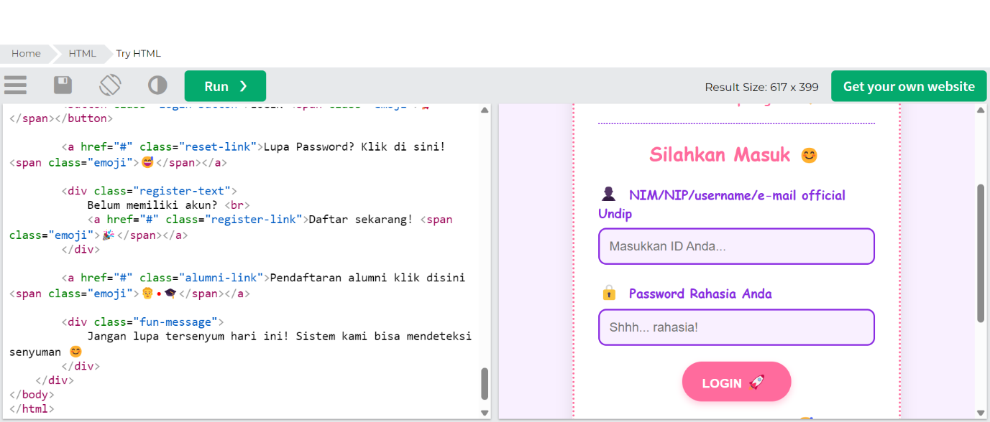</html>